**Assignment 1- Automated Instance Management Using AWS Lambda and Boto3**.

Setup:

   - Create two EC2 instances.

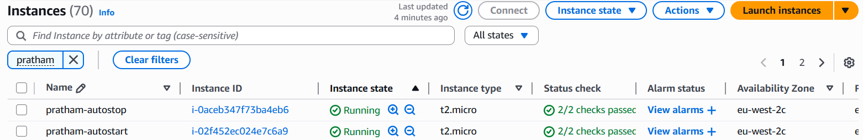

   - Tag one of them as `Auto-Stop` and the other as `Auto-Start`

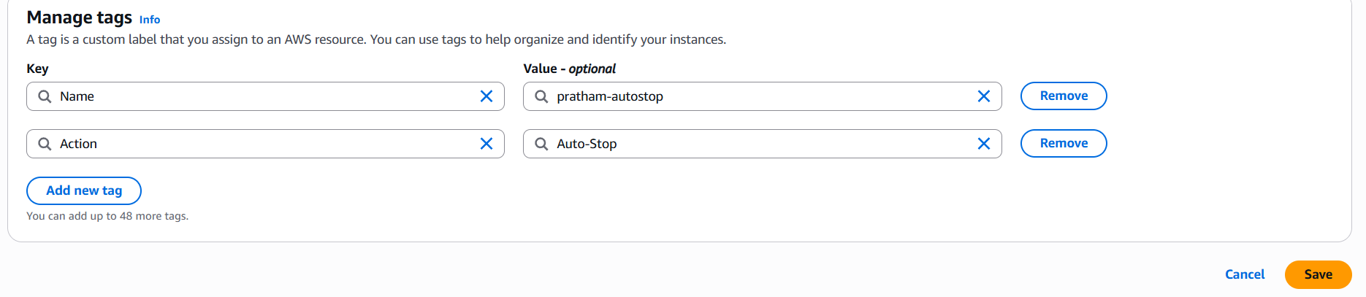

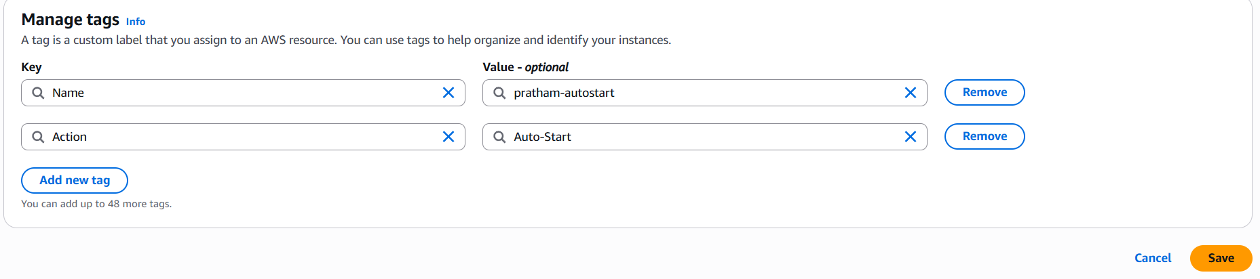

2. Lambda Function Creation:

   - Ensure that the Lambda function has the necessary IAM permissions to describe, stop, and start EC2 instances.

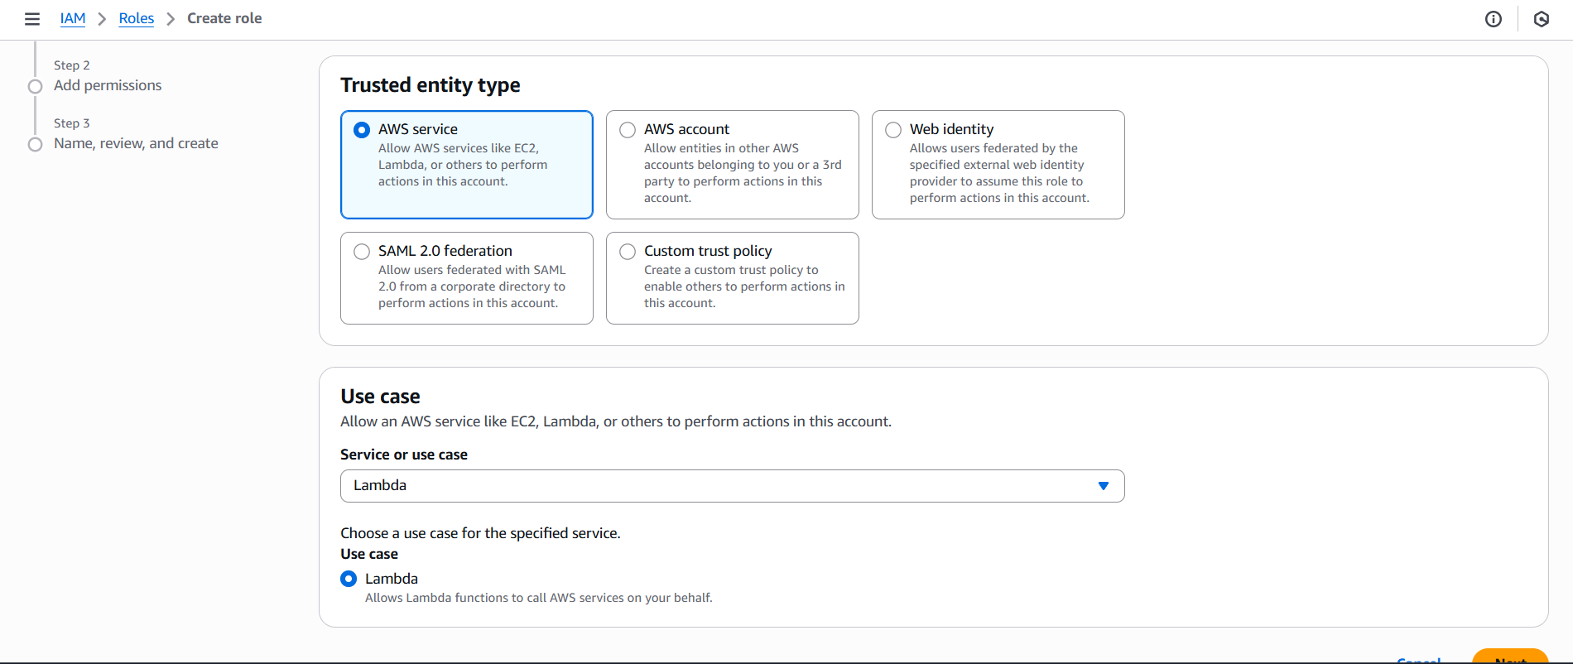

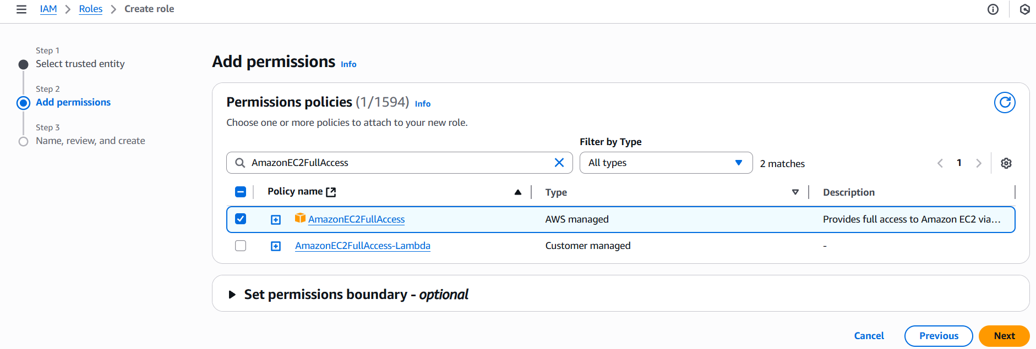

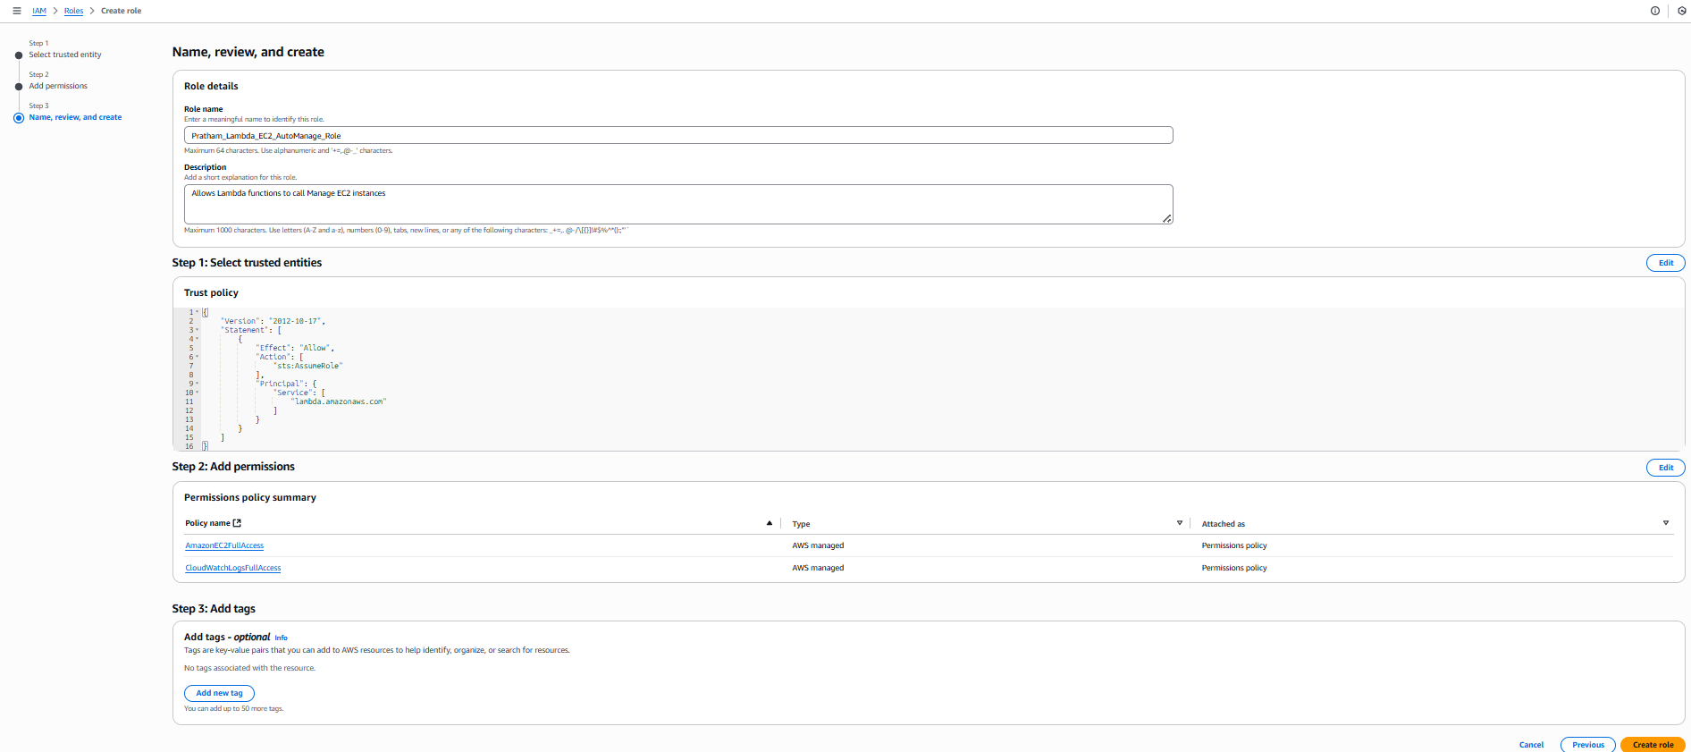

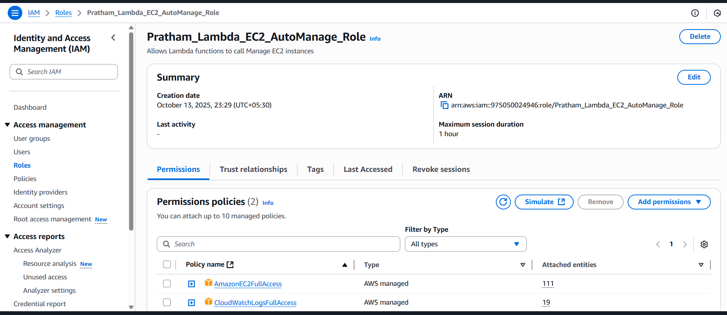

   - Set up an AWS Lambda function.

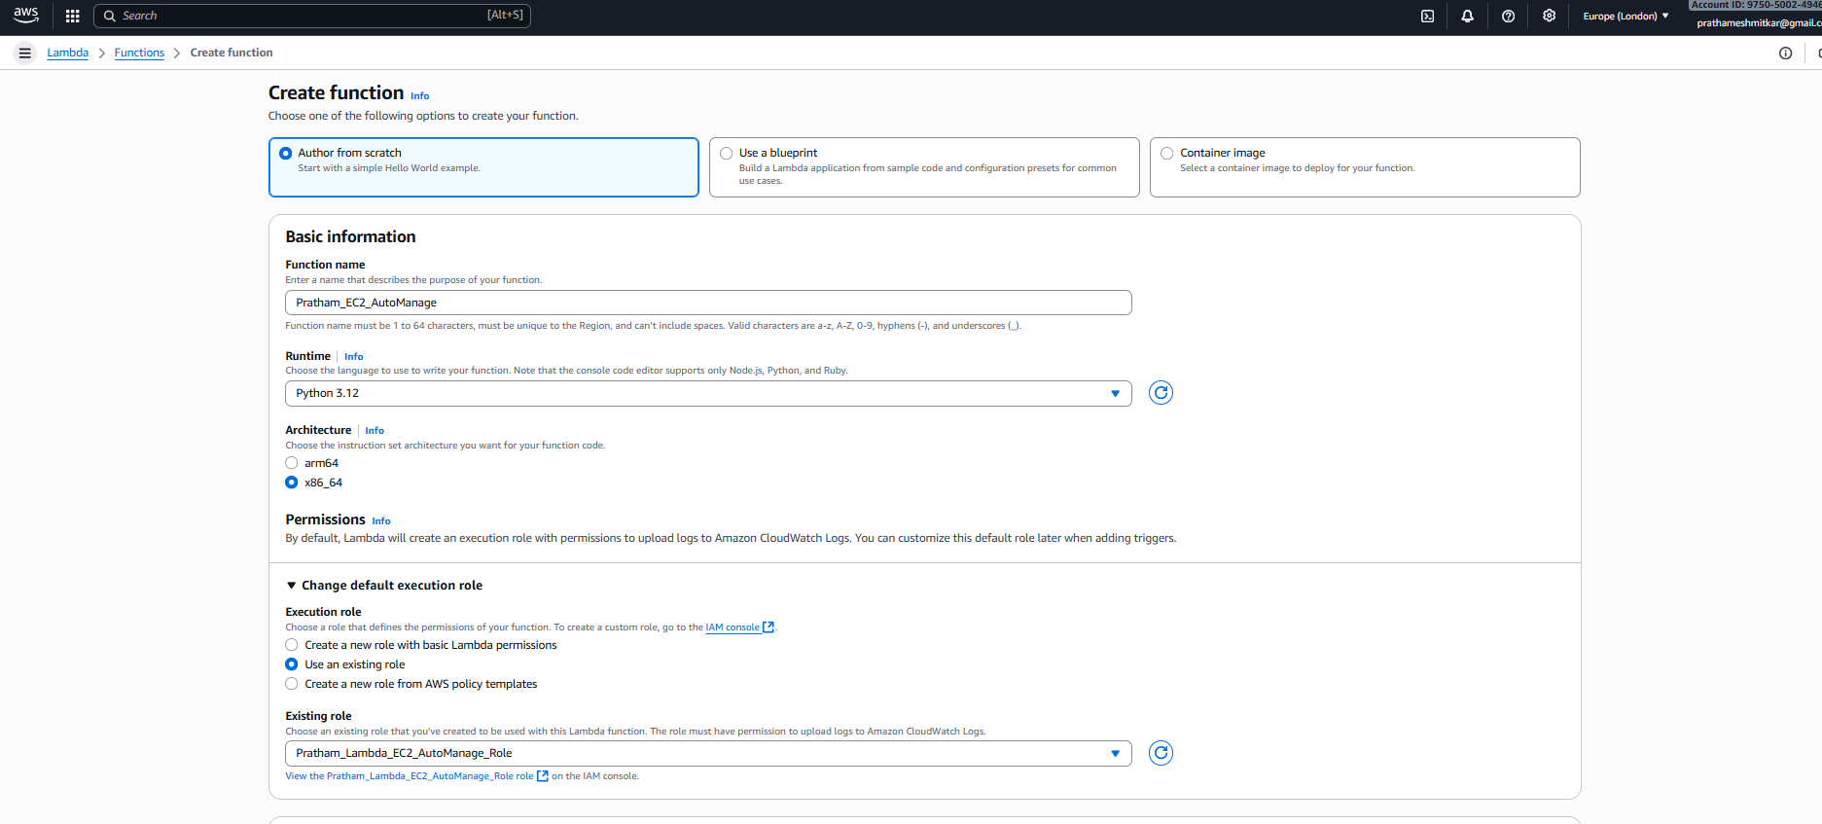

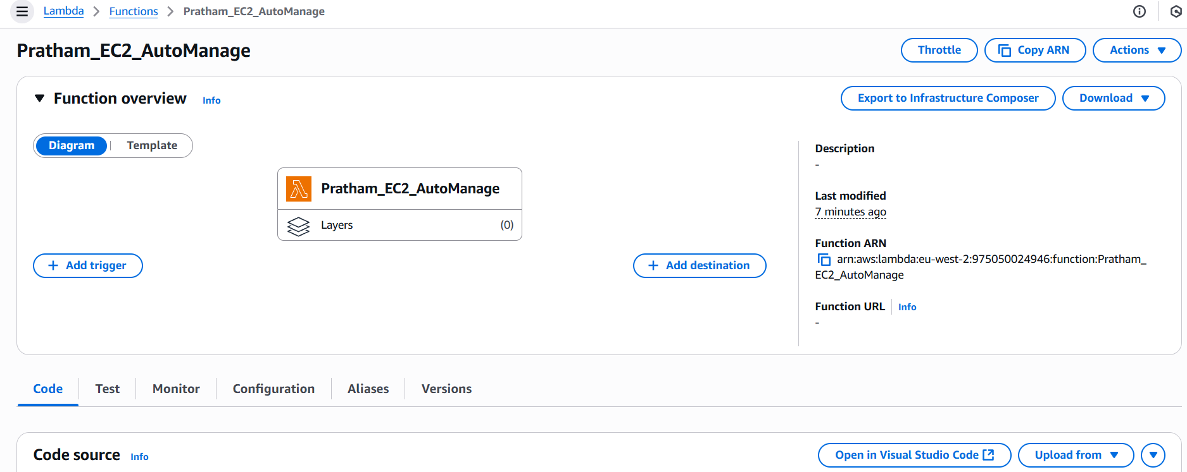

3. Coding:

   - Using Boto3 in the Lambda function:

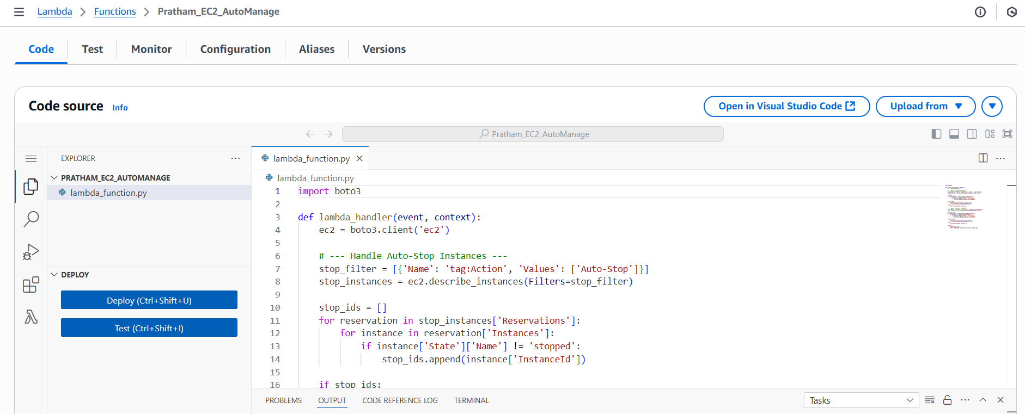

     - Detect all EC2 instances with the `Auto-Stop` tag and stop them.

     - Detect all EC2 instances with the `Auto-Start` tag and start them.



4. Testing:

   - Manually invoke the Lambda function.

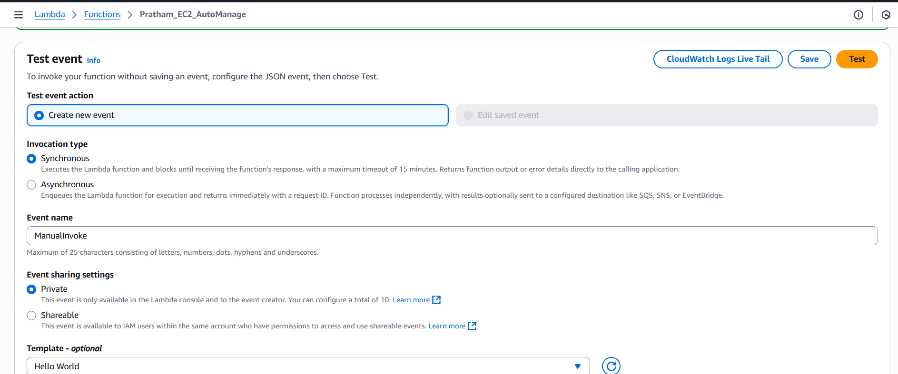

   - Confirm that the instance tagged `Auto-Stop` stops and the one tagged `Auto-Start` starts.

